TANYA
Department of Economics
Assistant Professor( Guest Faculty)
D.K. College, Dumraon (Buxar)
B.A. ECONOMICS – Part 1
Paper- 1 (Micro economics)
Topic – Law of Dimnishing Marginal Utility

LAW OF DIMNISHING MARGINAL UTILITY:

It is the foundation stone of Utility Analysis.
The law states that, other things being equal, the marginal utility (MU) of a good diminishes as more and more of it is consumed in a given time period.
But it should be noted that is the marginal utility (MU) that declines and not the total utility(TU) .
The law of diminishing MU means that TU increases but at a diminishing rate.

Hermann Heinrich Gossen was the first to formulate this law in 1854,though the name was given by Marshall.

The Law of Diminishing Marginal Utility, is derived from one of the characteristics of human wants. It is observed that although a person cannot satisfy all of his wants, he can satisfy one of those provided he has the means to do it. As he gets more and more of a thing ,his intensity of desire for that thing gradually diminishes, indicating that additional utility decreases as its total stock increases.

Example :

The table below presents the total and marginal utility derived by Ramesh from consuming cups of tea per day.
Quantity of Tea Consumed: | Total Utility  (Utils) | Marginal Utility  (Utils)
1 | 30 | 30
2 | 50 | 20
3 | 65 | 15
4 | 75 | 10
5 | 83 | 08
6 | 89 | 06
7 | 93 | 04
8 | 96 | 03
9 | 98 | 02
10 | 99 | 00
11 | 95 | -04

As seen in the table above, when Ramesh consumes one cup of tea in a day, he derives a total utility of 30 utils (unit of utility) and a marginal utility of 30 utils. When he takes two cups per day, the total utility rises to 50 utils but the marginal utility falls to 20. This trend continues until Ramesh Consumes 11th Cup of Tea where the marginal utility is negative. This means that if Ramesh consumes 11 or more cups of tea per day, then he might fall sick.

Here is a graph representing the table and depicting Dimnishing MU:

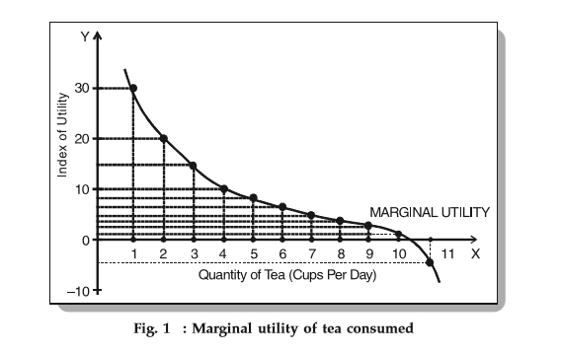

The graph clearly shows that on consuming 11th Cup of tea MU diminishes (turns negative).

The law of Dimnishing Marginal Utilty is the basic law of consumption.

Assumptions of the Law of Dimnishing MU:

The Law of Diminishing Marginal Utility is based on the following assumptions:

1. The utility that a consumer gets can be measured and expressed in numbers (utils). Moreover, the units of the commodity must be properly defined.
2. The maximum price a consumer is ready to pay for the commodity depends on its marginal utility to him.
3. The taste and preference of the consumer remain unchanged during the period of purchases.
Limitations of the law of diminishing MU:
- Homogeneous Units: - There should be a single commodity with homogeneous units wanted by an individual consumer.All units of Commodity should be of the same weight and quantity.
- No Change in Tastes – There should be no change in tastes, habit , custom and income of the consumers.
- Continuity – There should be continuity in consumption of the commodity.
- Indivisible Goods – The commodity should not be indivisible.
- Rational Consumer – The consumer should act rationally.

